**Project Mission Statement:**

WholesaleApp - to create a space for Singaporeans to rate and share about hawker food. This project aims to create an accessible platform for Singaporeans to choose delicious, budget-friendly, and healthy food options all around Singapore.

**Functional Requirements:**

1. The website must have a login page.
   1. Users must be able to login using their Google account.
   2. Users must be able to continue as a guest.
2. The website must have a homepage to display an overview of the features of the website.
   1. The homepage must be able to show hawker centres nearby based on the users’ location.
   2. The homepage must show recommended food nearby based on the users’ location.
   3. The homepage must show recent feeds posted by the users.
3. The website must have a search bar.
   1. Users must be able to search related keywords
      1. Users must be able to filter the results by hawker centres
         1. Users must be able to filter the hawker centres by distance
         2. Users must be able to filter the hawker centres by rating
      2. Users must be able to filter the results by food
         1. Users must be able to filter the food by price
         2. Users must be able to filter the food by rating
   2. The search bar must subtly guide users to the specific term they are looking for through type-as-you-go functionality.
      1. The functionality must suggest the top ranked search suggestion based on partial string the users have typed.
4. The website must have a map
   1. Google map API must be used
      1. Google map is being used to display the hawker centres distributed around Singapore.
         1. Users must be able to click on the hawker centres displayed on the map to see more details.
         2. Users must be able to rate the hawker centre under the displayed hawker centres’ profile.
         3. Users must be able to leave their comment about hawker centre.
   2. Users must be able to get navigation to selected hawker centres
      1. The website must display optimal route for vehicle.
      2. The website must display optimal route for public transport.
      3. The website must display optimal route on foot.
5. Users must be able to create post to share food or food stalls.
   1. Users can post photos for feed
   2. Users can post videos for feed
   3. Users must add location to their post

**Non-Functional Requirements:**

1. Usability
   1. The website should have colour schemes that are easy to see
      1. Light mode, where the page is primarily brighter colours
      2. Dark mode, where the page is primarily darker colours
2. Security
   1. The password should be of length of 8 with at least one letter, number and special character.
   2. Personal data of users should not be disclosed without permission.
   3. The website should automatically log the users out if there is a change in the linked Google account.
3. Performance
   1. The location accuracy should be within 50 metres.
   2. The search result should load within 10 seconds
4. Reliability
   1. The website should have an uptime of more than 98%

**Initial Use Case Diagram**

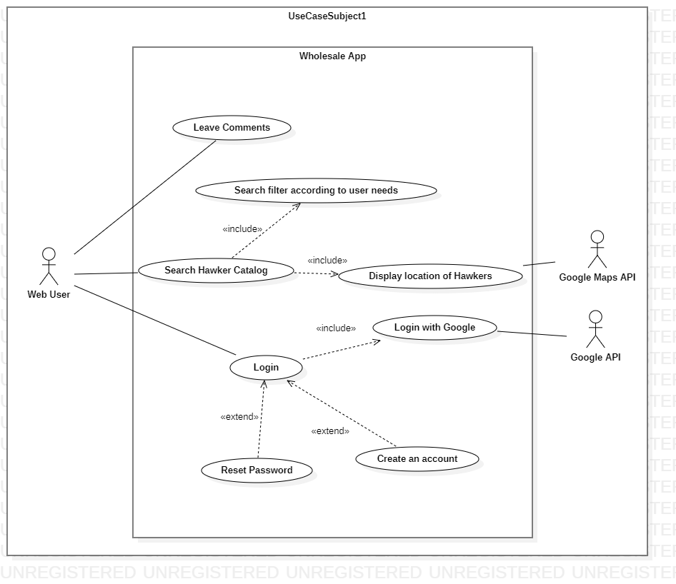

**Use Case Descriptions**

| Use Case ID: |  | TEMPLATE | | |
| --- | --- | --- | --- | --- |
| Use Case Name: |  | [FILL IN] | | |
| Created By: |  |  | Last Updated By: |  |
| Date Created: |  |  | Date Last Updated: |  |

| Actor: |  | [REQUIRED] |
| --- | --- | --- |
| Description: |  | [REQUIRED] |
| Preconditions: |  | [REQUIRED] |
| Postconditions: |  | [REQUIRED] |
| Priority: |  |  |
| Frequency of Use: |  |  |
| Flow of Events: |  | [REQUIRED] |
| Alternative Flows: |  | [REQUIRED] |
| Exceptions: |  |  |
| Includes: |  |  |
| Special Requirements: |  |  |
| Assumptions: |  |  |
| Notes and Issues: |  |  |

| Use Case ID: |  | 1 | | |
| --- | --- | --- | --- | --- |
| Use Case Name: |  | Search Hawker Catalog | | |
| Created By: |  | Zaki | Last Updated By: | Zaki |
| Date Created: |  | 26 Aug 2022 | Date Last Updated: | 29 Aug 2022 |

| Actor: |  | User |
| --- | --- | --- |
| Description: |  | User searches the database of hawker foods |
| Preconditions: |  | 1. User must be connected to WiFi/Mobile Data 2. User must be on the “Homepage” or “Search page” |
| Postconditions: |  | 1. User can view results pertaining to their search 2. User can gather information on related hawker stalls    1. Location    2. Price    3. Pictures 3. User can save the hawker stall to their favourites list |
| Priority: |  | Medium |
| Frequency of Use: |  | High |
| Flow of Events: |  | 1. User opens webpage 2. User clicks on search bar and makes a query 3. System checks user query against database 4. User is presented with hawker foods related to their query |
| Alternative Flows: |  | **AF-S1: User searches via search page**   1. User goes to search page 2. Return to step 2 |
| Exceptions: |  | - |
| Includes: |  | **Search Filter**   1. User may filter search results by various metrics    1. Location    2. Price    3. Calorie Count    4. Cuisine Type   **Display Hawker Location**   1. Using Google Maps API to present map of nearby hawkers 2. Display optimal route to nearby hawkers    1. On foot    2. By public transport    3. By vehicle |
| Special Requirements: |  | - |
| Assumptions |  | 1. Database has hawker stalls to query from    1. Submitted by other users |
| Notes and Issues |  | - |

| Use Case ID: |  | 2 | | |
| --- | --- | --- | --- | --- |
| Use Case Name: |  | Create a unique account | | |
| Created By: |  | Zaki | Last Updated By: | Zaki |
| Date Created: |  | 26 Aug 2022 | Date Last Updated: | 30 Aug 2022 |

| Actor: |  | User |
| --- | --- | --- |
| Description: |  | User creates an account on the web app to personalise their preferences and save hawker locations. Their account is transferable across devices and can be accessed remotely |
| Preconditions: |  | 1. User must be connected to WiFi/Mobile Data 2. User must be on the “Homepage” |
| Postconditions: |  | 1. User will have a unique account defined by a unique account username and password |
| Priority: |  | High |
| Frequency of Use: |  | Medium |
| Flow of Events: |  | 1. User opens webpage 2. User clicks “Create an account” 3. User enters their personal email 4. User enters a unique username 5. User enters a password 6. Username and password are logged into the database 7. Confirmation email is sent 8. User logs in using their unique username and password |
| Alternative Flows: |  | **AF-S4: Unique username already exists in the database**   1. User enters a different username 2. Return to step 5   **AF-S5: Password is not strong enough**   1. User is prompted for a different password 2. Password should contain at least 8 characters with a mixture of letters and numbers and inclusion of at least one special character 3. Return to step 6 |
| Exceptions: |  | - |
| Includes: |  | **Login with Google Account**   1. User logs in with pre-existing Google Account 2. Using Google API to validate user account 3. Refer to Use Case ID 6 |
| Special Requirements: |  | - |
| Assumptions |  | 1. User has a personal email |
| Notes and Issues |  | - |

| Use Case ID: |  | 3 | | |
| --- | --- | --- | --- | --- |
| Use Case Name: |  | Rate Hawker Centres | | |
| Created By: |  | Zaki | Last Updated By: | Zaki |
| Date Created: |  | 26 Aug 2022 | Date Last Updated: | 26 Aug 2022 |

| Actor: |  | User |
| --- | --- | --- |
| Description: |  | User rates the food from the hawker centres out of 5 stars after they have eaten the food. The user can upload photos of their food to share with other users. |
| Preconditions: |  | 1. User must be connected to WiFi/Mobile Data 2. User must have an account 3. User must be logged in to their account |
| Postconditions: |  | 1. User adds a food review to the database 2. Other users can access and view the review |
| Priority: |  | Low |
| Frequency of Use: |  | High |
| Flow of Events: |  | 1. User logs into their account 2. User clicks on “Review” button 3. User selects the location that they purchased food from 4. User selects a rating from 1 to 5    1. 1 representing a bad rating    2. 5 representing a good rating 5. User shares their review 6. Review is saved in the database |
| Alternative Flows: |  | **AF-S4: User shares a photo with their review**   1. User is prompted with a upload request 2. User can upload photos of their food 3. Return to step 5 |
| Exceptions: |  | - |
| Includes: |  | - |
| Special Requirements: |  | - |
| Assumptions: |  | 1. User has a file manager 2. User device has photos    1. Or device is capable of taking photos |
| Notes and Issues: |  | - |

| Use Case ID: |  | 4 | | |
| --- | --- | --- | --- | --- |
| Use Case Name: |  | Leave comments about hawker centres | | |
| Created By: |  | Zaki | Last Updated By: | Zaki |
| Date Created: |  | 26 Aug 2022 | Date Last Updated: | 30 Aug 2022 |

| Actor: |  | User |
| --- | --- | --- |
| Description: |  | Users can leave comments on other food reviews. |
| Preconditions: |  | 1. User must be connected to WiFi/Mobile Data 2. User must have an account 3. User must be logged in to their account |
| Postconditions: |  | 1. User leaves comments on other food reviews 2. Other users can view comments and leave comments of their own |
| Priority: |  | Medium |
| Frequency of Use: |  | High |
| Flow of Events: |  | 1. User logs into their account 2. User selects “Review” page 3. User is presented with reviews submitted by other users 4. User selects a review 5. User clicks on the “Comment” button 6. User writes a comment    1. Comments can contain text and emoticons 7. User submits the comment 8. Comment is saved in the database and tagged to the review |
| Alternative Flows: |  | **AF-S6: Comment contains offensive words**   1. Comments that contain offensive words are flagged 2. User will be prompted to change the phrasing of their comment 3. Return to step 7 |
| Exceptions: |  | - |
| Includes: |  | - |
| Special Requirements: |  | - |
| Assumptions: |  | 1. Database has reviews to query from    1. Submitted by other users |
| Notes and Issues: |  | - |

| Use Case ID: |  | 5 | | |
| --- | --- | --- | --- | --- |
| Use Case Name: |  | Log into account using email and password | | |
| Created By: |  | Zaki | Last Updated By: | Zaki |
| Date Created: |  | 26 Aug 2022 | Date Last Updated: | 30 Aug 2022 |

| Actor: |  | User |
| --- | --- | --- |
| Description: |  | User logs into their account using a unique username and password. |
| Preconditions: |  | 1. User must be connected to WiFi/Mobile Data 2. User must have an account 3. User must be on the “Homepage” |
| Postconditions: |  | 1. User is able to log into their account and retrieve their information and preferences 2. User is able to post reviews and comments |
| Priority: |  | High |
| Frequency of Use: |  | Medium |
| Flow of Events: |  | 1. User clicks on the “Login” button 2. User is presented with fields to enter their username and password 3. User enters their username 4. User enters their corresponding password 5. Information is validated against database 6. User logs in successfully |
| Alternative Flows: |  | **AF-S3: Username does not exist**   1. User is presented with an error message 2. User is prompted to enter their username again 3. Return to step 3   **AF-S4: Password is incorrect**   1. User is presented with an error message 2. User is prompted to enter their password again 3. Return to step 4   **AF-S4: Forgot password**   1. User is presented with an error message 2. User clicks on “Forgot password” 3. Refer to Use Case ID 8 |
| Exceptions: |  | - |
| Includes: |  | **Login with Google Account**   1. User logs in with pre-existing Google Account 2. Using Google API to validate user account 3. Refer to Use Case ID 6 |
| Special Requirements: |  | - |
| Assumptions: |  | - |
| Notes and Issues: |  | - |

| Use Case ID: |  | 6 | | |
| --- | --- | --- | --- | --- |
| Use Case Name: |  | Log into account using Google Account | | |
| Created By: |  | Zaki | Last Updated By: | Zaki |
| Date Created: |  | 26 Aug 2022 | Date Last Updated: | 30 Aug 2022 |

| Actor: |  | User |
| --- | --- | --- |
| Description: |  | User logs into web page using their Google Account. |
| Preconditions: |  | 1. User must be connected to WiFi/Mobile Data 2. User must have a Google Account 3. User must be on the “Homepage” |
| Postconditions: |  | 1. User is able to log into their account and retrieve their information and preference 2. User is able to post reviews and comments |
| Priority: |  | High |
| Frequency of Use: |  | Medium |
| Flow of Events: |  | 1. User clicks on the “Login” button 2. User is presented with fields to enter their username and password 3. User selects “Login with Google” 4. System validates account by checking against Google Database via Google API 5. User must grant permission to access their Google Account information 6. System will use Google Account details to save information and preferences 7. User logs in successfully |
| Alternative Flows: |  | **AF-S4: User enters their Google Account incorrectly**   1. Google API will prompt the user to enter their credentials again 2. User enters their credentials again 3. Return to step 4 |
| Exceptions: |  | - |
| Includes: |  | **Validate Account**   1. Google Account credentials will be validated using Google API |
| Special Requirements: |  | - |
| Assumptions: |  | - |
| Notes and Issues: |  | - |

| Use Case ID: |  | 7 | | |
| --- | --- | --- | --- | --- |
| Use Case Name: |  | Show top rated hawker centres nearby | | |
| Created By: |  | Zaki | Last Updated By: | Zaki |
| Date Created: |  | 26 Aug 2022 | Date Last Updated: | 30 Aug 2022 |

| Actor: |  | User |
| --- | --- | --- |
| Description: |  | User is shown recommendations of hawker centres based on location and ratings. |
| Preconditions: |  | 1. User must be connected to WiFi/Mobile Data 2. User must have location on their device enabled 3. User must be on the “Homepage” |
| Postconditions: |  | 1. User can view a list of top rated hawkers 2. User can save results to their favourites |
| Priority: |  | Medium |
| Frequency of Use: |  | High |
| Flow of Events: |  | 1. User clicks on the “Top Rated” page 2. System queries the database, returning listings based on location and rating 3. User is presented with hawker stalls rated 4 stars and above, within 1km of their location |
| Alternative Flows: |  | **AF-S1: Database doesn’t contain any entries**   1. User is presented with message stating that there are no results |
| Exceptions: |  | - |
| Includes: |  | - |
| Special Requirements: |  | - |
| Assumptions: |  | - |
| Notes and Issues: |  | - |

**Data Dictionary**

| Field Name | Data Type | Data Format | Field Size | Description | Example |
| --- | --- | --- | --- | --- | --- |
| Hawker Centre | Text | - | 100 | An open air market at which individual vendors sell ready-to-eat food from small booths | Maxwell Food Centre |
| Account | Text | - | - | A unique profile that stores a user’s personal information and saved information in the app | - |
| Unique Account Username | Text | - | 20 | A unique identifier used to gain access to a computer, network or online system | Lim Jun Jie |
| Account Password | Text | At least 8 characters with a mixture of letters and numbers and inclusion of at least one special character | 20 | A string of characters used to verify the identity of a user during the authentication process. | 8xiJ55KE#oz |
| Rating | Category | Integer value from 1 to 5 | 1 | Classification of a hawker food stall based on the user’s impression of their food | 3 |
| Comment | Text |  | 200 | Written remark expressing an opinion or reaction of a hawker food stall by the user | Fresh fish soup with rice, porridge, or bee hoon is available. The soup broth was delicious, and it was cooked to perfection |
| Distance | Integer | Kilometers | 2 | Physical distance between the user and the desired hawker  centre | 3.2 kilometers |
| Region | Category | North, North-East, South, East, West or Central | 20 | Urban planning subdivisions demarcated by the Urban Redevelopment Authority of Singapore | North-East |
| Type of Diet | Category | Non-Halal, Halal, Vegetarian or Vegan | 20 | The kinds of food that a person habitually eats | Vegan |